2019‘创之盟’中德创新创业大赛
智慧交通及信息技术领域
参赛项目汇编

合作对接平台：
国际技术转移协作网络（ITTN）
www.ittn.cn

2019 China-Germany‘InnoAlliance’
Smart Traffic & IT
Projects Introduction

Cooperation and Matchmaking Platform：

International Technology Transfer Network（ITTN）
www.ittn.cn

目录
1. peaq : 可扩展、分散的DAG/区块链业务基础层 4
2. UrmO: 可折叠自平衡轻型电动车 4
3. Smartivate: 即插即用智能家居设备配置器 5
4. Solmove GmbH: 为电动汽车提供动力的智能太阳能道路 7
5. Quick Turn Studio GmbH: 为UI开发解决方案的软件公司 8
6. Robot4Work：推广机器人员工服务 9
7. Arox Solutions GmbH：自动化羽毛球组织管理工具 10
8. AtoBCarry Holding GmbH: 基于AI的供应链交通管理系统 11
9. landopay: 智能财务管理 12
10. SAYM Mobility GmbH i.G.: 日常拼车平台 13

peaq : 可扩展、分散的DAG/区块链业务基础层
关键词：区块链项目底层架构设计，自研算法，区块链场景应用。
项目简介：
通常我们提供公共peaq网络，基于许可模式的企业产品。 具体而言，标准锚定企业网络，定制锚定企业网络和公共网络的一般使用。 Peaq是第一个高效，分散的分布式分类帐技术网络。DAG（定向非循环图）和区块链都不符合公司采用的所有技术要求。 经过多年的研究和测试，我们提出两种技术的创新组合作为最佳解决方案。 peaq协议是第一个根据行业要求构建的DAG-Blockchain混合基础层解决方案，我们将其称为DAGChain。与Advanced Blockchain AG的动态业务实施框架一起，我们的目标是为现实世界中的企业实施peaq，为他们提供分散但同时快速，安全和私密的解决方案。
Project introduction:
Generally we offer the public peaq network, with enterprise products based on a licensing model. Specifically, standard anchored enterprise networks, custom anchored enterprise networks and general usage of the public network for the public. Peaq is the first efficient and decentralized Distributed Ledger Technology network for business.
Neither DAGs(Directed Acyclic Graph) nor blockchains meet all technical requirements for corporate adoption. After years of research and testing, we’re proposing an innovative combination of both technologies as the most optimal solution. The peaq protocol is the first DAG-Blockchain hybrid base-layer solution built to industry requirements, and we’ve called it the DAGChain.
Together with Advanced Blockchain AG's dynamic business implementation framework we aim to implement peaq for businesses in the real world, providing them with a decentralised but simultaneously fast, secure and private solution.
Time established: 2017.04
Raising Fund: $ 5M
Cooperation Need: market development
Website: peaq.io/
成立时间：2017.04
融资额：$ 5M
合作需求：市场开发
网址：peaq.io/

UrmO: 可折叠自平衡轻型电动车
关键词：平衡车
项目简介：
城市化是一个持续的趋势。随之而来的是我们的城市变得更大，人口更密集。到2030年，世界上80％以上的人口将居住在城市。因此，更多的人需要分享道路空间，拥堵将更严重。拥挤的高速公路已经成为我们旅程的一部分。
UrmO是世界上第一款可折叠自平衡轻型电动车。不驾驶时，它可以简单地折叠并随身携带，例如火车或地铁。这意味着人们将更加独立，并将节省他们的日常通勤时间。
基本上，UrmO就像Segway一样工作，所以它是通过改变重量来控制的。你向前倾斜加速，你向后倾斜以打破或逆转。左右转向是通过转向您想要的方向来完成的。我们的智能和正在申请专利的转向机构既简单又直观。
我们已获得四项实用专利，与德国汽车OEM合作，以及UrmO获得德国eKFV认证，这意味着我们符合个人轻型电动车道路审批的最高标准。
Project introduction:
Urbanisation is an ongoing trend. With that our cities become larger and more densely populated. By 2030, more than 80% of the first world population will live in cities. Thus, more people need to share the road space and congestion will get worse. Crowded highways are part of our journeys as it is already.
The UrmO is the world’s first foldable self-balancing light electric vehicle. When not driving, it allows you to simply fold it and carry it everywhere for example to the train or subway. And that means that people will be more independent and will save time on their daily commute.
Basically, the UrmO works like a Segway, so it is controlled by shifting weight. You lean forward to speed up and you lean backwards to break or reverse. Steering left and right is accomplished by turning into the direction you want to go. Our intelligent and patent-pending steering mechanism is both simple and intuitive.
We have secured four utility patents, a partnership with a German automotive OEM and the fact that UrmO received the German eKFV certification means that we comply with the highest standards in road approval for personal light electric vehicles.
Time established: 2016.03
Raising Fund: € 1.5M
Cooperation Need: products development, market development, investment
Website: www.my-urmo.com
成立时间：2016.03
融资额：€ 1.5M
合作需求：产品开发、市场开发、融资网址：www.my-urmo.com

Smartivate: 即插即用智能家居设备配置器
关键词：兼容的跨品牌智能家居设备终端配置
项目简介：
Smartivate的理念是在研究了终端用户在选择兼容设备以使家庭更智能方面所面临的困难之后发展起来的。智能家居产品数以百计，每一种产品都有自己的协议和通信标准(如Wifi, Zigbee, Z-wave，蓝牙……)，这使得房主或租户很难进行购买。可能会发生这样的情况:一个顾客买了6种不同的产品，需要安装4个应用程序，但仍然不能在一次点击中自动完成他/她的家!为了避免这种情况，并提供更多的购买灵活性，我们开发了一个简单但创新的智能家居配置。
在Smartivate，已经建立了第一个即插即用智能家居设备配置器。我们的配置器引导用户通过问题和相关信息在智能家居世界&直观地了解客户的需求。在回答几个问题后，用户将立即得到量身定制的产品解决方案(包)，其中包括一套兼容的跨品牌智能家居设备，基于客户的喜好、预算，更重要的是，现有的家庭基础设施。使得家庭变得智能、安全、舒适。
作为现有在线智能家居配置平台的延伸，我们通过在智能家居和能源管理系统之间建立接口，支持公用事业公司为客户创建数字化管理服务。这将包括使智能技术(IoT)与光伏安装和电池系统在家中互操作。
Project introduction:
The idea of Smartivate evolved after looking into the struggles faced by end users in choosing compatible devices to make their homes smart. There are hundreds of manufacturers with thousands of smart home products & every product has its own protocol & communication standard (such as Wifi, Zigbee, Z-wave, Bluetooth...), which makes it difficult for a home owner or tenant to make a purchase. It can so happen that a customer buys 6 different products & needs to install 4 apps and still cannot automate his/her home in just one click! To avoid this frustration and provide more flexibility in purchase, we have developed a simple yet innovative smart home configurator.
We, at Smartivate, have built the first configurator for plug & play smart home devices. Our configurator guides users through questions and relevant information in the Smart Home world & intuitively understands the needs of a customer. On answering a few questions, users will immediately be provided with tailor-made product solutions (packages) that include a set of compatible cross-branded smart home devices based on customers' preferences, budget & more importantly, existing home infrastructure. This smoothly enable homes to be intelligent, secure and comfortable.
As an extension to the existing online Smart Home configurator platform, we support Utility companies in creating digitally managed services for its customers by building an interface between Smart home & an energy management system. This would involve making smart technologies (IoT) interoperable with PV installations & battery systems in the house. Thus, making the idea of a fully connected home a reality.
Time established: 2018.02
Raising Fund: € 480000
Cooperation Need: products development, market development
Website: smartivate.de/
成立时间：2018.02
融资额：€ 480000
合作需求：产品开发、市场开发
网址：smartivate.de/

Solmove GmbH: 为电动汽车提供动力的智能太阳能道路
关键词：太阳能设备，智慧交通
项目简介：
Solmove开发了一种防碎的水平光伏组件，可以在车道、自行车道和其他现有交通区域等平面上行驶并粘接。将太阳能组件带到道路上允许双重使用密封区域(发电和交通)。由于双重利用了封闭区域，潜在的农业可用区域得以保留。
如果道路上仍然装有传感器，它就会变成一条智能道路。今后还将增加更多的功能。例如，用于节省冬季道路通行的除霜功能，用于显示交通标志和提高安全性的集成照明，用于控制自动驾驶车辆和道路之间的交通流量或数据交换的传感器(基础设施/平台即服务= PaaS)。PaaS将被设计为一个开放系统，以便其他提供者也可以通过该平台提供服务。
我们建造智能太阳能街道，为电动汽车提供信息和电力。Solmove开发了一种坚固的水平光伏组件，可以驱动并固定在车道、自行车道或其他现有交通区域等平面上。Solmove的光伏组件是多功能的，可以配备加热、照明和传感器。下一个大的发展是将这些模块与电动汽车的动态感应充电相结合。然后产生的电能将通过感应(感应)无线传输给电动汽车，以提高用户的舒适度。无再需电缆给电动汽车充电。
Project introduction:
Solmove has developed a break-proof, horizontal photovoltaic module that can be driven over and glued on flat surfaces such as driveways, bike paths, and other existing traffic areas. Bringing the solar modules onto the road allows a double use of sealed areas (power generation and traffic). With the double use of sealed areas, potentially usable areas for agriculture are preserved.
If the road is still equipped with sensors, it becomes a smart road. Further functions will be added in the future. For example, a defrost function to save winter road clearance, integrated lighting to display traffic signs and to improve safety, sensors to control traffic flow or data exchange between autonomous vehicles and the road (Infrastructure/platform as a service = PaaS). PaaS is to be designed as an open system so that other providers can also offer their services via the platform.
We build smart solar streets that generate information and electricity to power e-vehicle. Solmove has developed a solid, horizontal photovoltaic module that can be driven over and fixed on flat surfaces such as driveways, bike paths, and or other existing traffic areas. The PV modules from Solmove are multifunctional, they can be equipped with heating, light and sensors. The next big development step is the combination of the modules with dynamic inductive charging for e-cars. Then the produced electricity will be transmitted wirelessly (via induction) to e-vehicles (initially while standing - this already works - later while driving) in order to improve comfort for users. No more cables to charge the e-car.

Quick Turn Studio GmbH: 为UI开发解决方案的软件公司
Time established: 2014.01
Raising Fund: € 2M
Cooperation Need: market development
Website: www.solmove.com
成立时间：2014.01
融资额：€ 2M
合作需求：市场开发
网址：www.solmove.com
关键词：软件开发工具，UI自动化工具，应用软件开发公司，云服务商
项目简介：
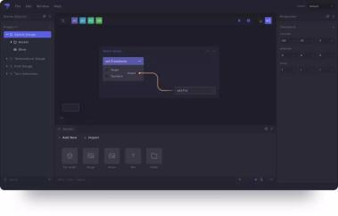
SevenIDE是一种用于为软件应用程序创建用户界面的可视化工具。例如，数字仪表组，信息娱乐系统，HMI，HUD，还包括机械工程和其他。应用程序（Studio）使用由QTS开发的引擎，该引擎包含一个包含应用程序所需组件的库。对于引擎的开发，Grabowski先生受到了广泛的游戏引擎的启发，并且能够为用户开发直观的应用程序。 SevenIDE将支持自动UI测试，实时，应用程序预览也可以在VR模式下查看。 SevenIDE将支持Windows，Linux和MacOS上的应用程序开发。先进的架构允许用户轻松测试组件。完整的产品将具有易于理解的文档以及准备充分的教程。
该软件作为SaaS模型提供，在客户的计算机上安装，客户支付许可费。该软件既可以通过下载安装，也可以在特殊情况下通过外部介质（例如CD，PenDrive）提供给客户。
SevenIDE由三部分组成：
- SevenIDE Studio（工作流程）;
- SevenIDE引擎（API和库）;
- SevenIDE VR模拟。
Project introduction:
SevenIDE is a visual tool for creating user interfaces for software applications. These include, for example, the digital instrument clusters, infotainment systems, HMIs, HUDs but also in mechanical engineering and others. The application (Studio) uses an engine developed by QTS, which contains a library containing the components necessary for the application. For the development of the engine, Mr. Grabowski was inspired by widespread game engines and was able to develop an application that is intuitive for users. SevenIDE will support automated UI testing and real-time, application preview can also be viewed in VR mode. SevenIDE will support application development on Windows, Linux and MacOS. Sophisticated architecture allows users to easily test components. The complete product will have well-understandable documentation as well as well-prepared tutorials.
The software is offered as a SaaS model with an installation on the customer's computer and the customer pays a license fee. The software can either be installed by download or, in exceptional cases, given to the customer on an external medium (eg CD, PenDrive) (see also 5.2 Price Policy).
SevenIDE consists of three parts:
- SevenIDE Studio (Workflow);
- SevenIDE Engine (APIs & Libraries);
- SevenIDE VR Simulation.
Time established: 2018.11
Raising Fund: € 500000
Cooperation Need: products development
Website: quickturnstudio.com/
成立时间：2018.11
融资额：€ 500000
合作需求：产品开发
网址：quickturnstudio.com/

Robot4Work：推广机器人员工服务
关键词：机器人，客服机器人，助理机器人
项目简介：
Robot4Work机器人服务公司为酒店、餐厅、零售店、博物馆、医院、学校、购物中心等酒店和服务行业的公司提供人形机器人员工，作为前台接待人员、迎新人员或零售销售助理，以提高工作效率和客户满意度。我们的机器人可以全天与人类、传感器和所有设备无缝同步工作。此外，我们还为机器人配备了人力支持团队，以监控机器人并了解业务和客户的需求，以便在需要帮助的情况下提供帮助。如果机器人两次听不懂命令，可以人为在几秒钟内通过互联网解决客户的要求。机器人可以自主工作，但我们的人工支持团队确保它全天的的工作质量。Robot4Work通过谷歌语音API支持48种语言。
Project introduction:
Robot4Work Robotic Services provide humanoid robot employees to companies in the Hospitality and Service sector such as hotels, restaurants, retail stores, museums, hospitals, schools, shopping malls, etc as receptionist, welcome staff or a retail sales assistant to improve workflow efficiency and customer satisfaction. Our robots can work 7/24 synchronized with human employees, sensors and all devices seamlessly. Also, we backed the robots with a human support team to monitor the robots and understand the business and customer needs in case of any help needed. If a robot doesn’t understand a command 2 times, a human operator solves the customer’s request in seconds via the internet. Robots are able to work autonomously but our human support team just allow it to reach the excellent quality of work 24/7. Robot4Work support 48 languages by Google Voice API.

成立时间：2017.01
融资额：€ 200K
合作需求：产品推广
网址：http://robot4work.com/

Time established: 2017.01
Raising Fund: € 200K
Cooperation Need: products promotion
Website: http://robot4work.com/

Arox Solutions GmbH：自动化羽毛球组织管理工具
关键词：羽毛球活动管理软件，羽毛球生产物联网，自动化工具
项目简介：
所有羽毛球活动组织，无论是在亚洲，欧洲还是美国，都在日常工作中遇到类似的挑战。他们都在努力解决有问题的立法，组织缓慢或事件管理不善。非专业设置，人力资源减少，并且难以追溯的会员资格支付会影响组织的运作方式。最后但并非最不重要的是，他们的整体形象和演示，包括他们的网站，往往不发达甚至缺失。
Badmintoo是一个基于订阅的在线ERP系统，可以促进利润和非营利性羽毛球组织的日常挑战。 Badmintoo提供自动化而定制的解决方案，可帮助您应对组织每天可能面临的所有挑战。使用Badmintoo，每个组织都将获得自定义的合法化，包括与其注册国家/地区兼容的帐户图表。他们将获得自定义徽标，网页设计和整体企业形象。 Badmintoo还提供活动，帐户和人力资源管理等等。
Badmintoo是一款自动化工具，可帮助您以简单，高效，优化和节省成本的方式管理和系统化您的羽毛球组织！
Badmintoo连接不同的Raspberry PI控制器，因此您还可以控制不同类型的硬件 - 如智能湿度盒，在线计数系统或羽毛球服装和设备生产线。Raspberry PI控制器，它们背后的服务器和固件是我们自己的研发和正在申请专利的立法。
Project introduction:
All badminton organisations, no matter if they are in Asia, Europe or America, experience similar challenges in their everyday work. They all struggle with problematic legislation, slow organisation or poor management of events. Having non-professional setup, fewer human resources, and hardly traceable membership payments affect how the organisation functions. Last but not least their overall image and presentation, including their website, is often underdeveloped or even missing.
Badmintoo is a subscription-based online ERP system that can facilitate profit and non-profit badminton organisations with their day-to-day challenges. Badmintoo offers automated yet custom solutions which can help you tackle all the challenges your organisation might face daily. With Badmintoo, each organisation will get customised legalisation, including charts of accounts compatible with the country they are registered. They will receive a custom logo, web design and overall corporate identity. Badmintoo also offers event, account and HR management and much more.
Badmintoo is an automated tool that helps you manage and systematise your badminton organisation in an easy, efficient, optimized and cost-saving way!
Badmintoo connects different Raspberry PI controllers so you can also control different types of Hardware - like the Smart Hygro boxes, Online counting system, or a Production line for Badminton Clothing and Equipment.
The Raspberry PI controllers, the servers behind them and the firmware are our own R&D and are under patenting legislation.
Time established: 2017.05
Raising Fund: € 550000
Cooperation Need: products development
Website: www.arox-solutions.de
成立时间：2017.05
融资额：€ 550000
合作需求：产品开发
网址：www.arox-solutions.de

AtoBCarry Holding GmbH: 基于AI的供应链交通管理系统
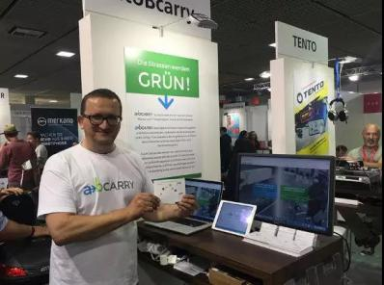
关键词：人工智能，供应链交通管理系统
项目简介：
AtoBCarry将供应链数字化，使其实时透明。这使得更有效的规划成为可能。
我们主要提供动态码管理：
需要解决什么问题?
•卡车司机不必要的等待时间和前面/里面卡车的停机时间
生产基地
•生产现场供应灵活，以防出现瓶颈
•稳定利用进出库货物区域
Project introduction:
AtoBCarry digitizes the supply chains and makes them transparent in real time. This enables more efficient planning
Dynamic Yard Management
What problem needs to be solved?
• Unnecessary waiting times of truck drivers and downtimes of the trucks in front of/ in
the production sites
• Flexible supply of the production site in case of bottlenecks
• Steady utilization of incoming goods and outgoing goods areas
Time established: 2017.01
Raising Fund: € 2500000
Cooperation Need: market development
Website: www.atobcarry.com
成立时间：2017.01
融资额：€ 2500000
合作需求：市场开发
网址：www.atobcarry.com

landopay: 智能财务管理
关键词：智能财务管理，智能信用卡
项目简介：
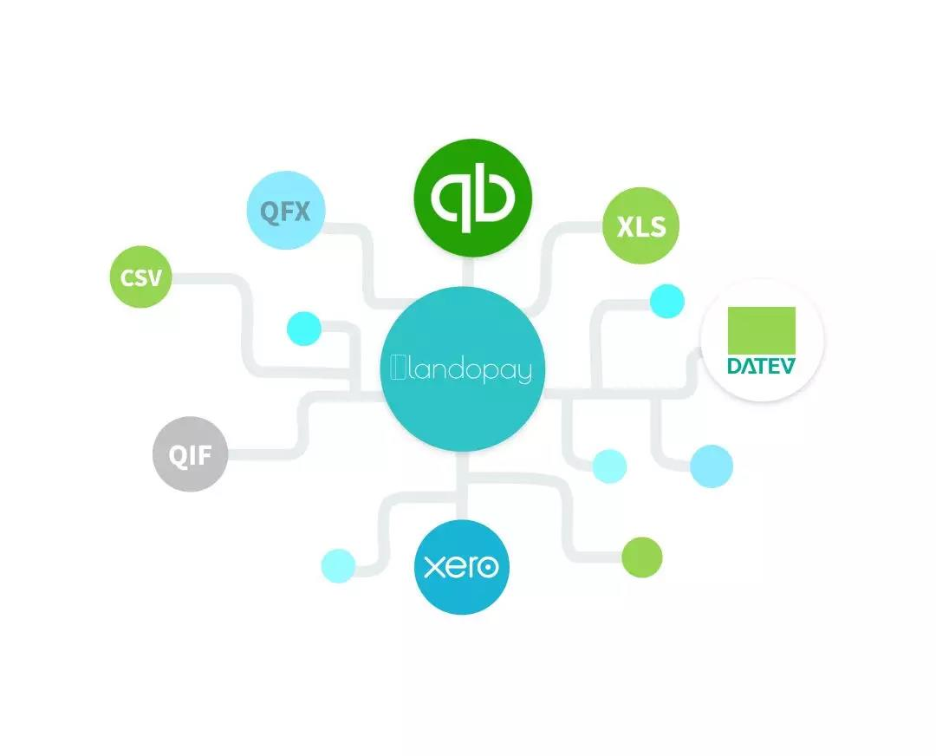
Landopay不区分费用管理和具有预批准流程的采购,将其集成到一个工具中。
时间就是金钱。今天花在管理开支上的时间太多了。经理、行政人员和员工会在文书工作、限制和不明确的审批流程中迷失方向。谁花了什么时间？谁批准？为什么只有一定数量？此外，员工必须提前支付他们的许多费用。
Landopay为这一耗时且繁琐的流程提供了一个解决方案——一种创新的智能信用卡，它可以自动捕捉费用，对其进行分类并将其集成到报表中，然后将其导出到通用的簿记软件中。哦，我们是否提到过，我们还提供了直接在卡上预先设置预算和预先批准的能力！
注册后，每个用户都会收到一张单独的卡。用户用一个正常的IBAN传输加载他们的landoPay帐户。然后，定义公司政策，按卡片（也可以按支出类别）设置单个预算，从而提供前所未有的控制和可视性。Landopay将所有费用集中在现代用户界面中，以便企业能够实时查看其支出，计划预算并跟踪从订单到付款的支出。
Project introduction:
landopay does not differentiate between expense management and purchasing with pre approval process. landopay integrates it into one tool.
Time is money. and too much time is spent on managing expenses today. Managers, admins and employees get lost in paperwork, limits and unclear approval processes. Who spent what and when? Who approves and why only a certain amount? In addition, employees have to pay in advance for many of their expenses.
Landopay offers a solution to this time-consuming and cumbersome process - an innovative smart credit card that automatically captures expenses, categorizes and integrates them into reports which can be exported into common bookkeeping software. Oh did we mention that we also offer the ability to set budgets and pre-approvals in advance directly on the card!
After registration each user receives an individual card. Users load their landopay account with a normal IBAN transfer. Then, company policies are defined, individual budgets are set by card (and optionally by spend category) giving you unprecedented control and visibility. Landopay centralizes all expenses in a modern user interface so that businesses can see their spend in real time, plan budgets and track expenses from order to payment.
Time established: 2019.01
Raising Fund: € 500K
Cooperation Need: market development, products development
Website: landopay.com
成立时间：2019.01
融资额：€ 500K
合作需求：市场开发、产品开发
网址：landopay.com

SAYM Mobility GmbH i.G.: 日常拼车平台
关键词：拼车平台
项目简介：
SAYM是一个拼车平台，每天都可以拼车，把有相同路线的人连接起来。该平台通过实现自动管理和简单的旅程网络协调，特别针对通勤者和他们的日常工作方式。一种创新的匹配算法将每天都在同一条路线上但从未谋面的合适的人连接起来。
SAYM确保交通工具总是可用的，并且总是能够到达预期的目的地。为此目的，在SAYM平台上捆绑了公共交通连接、共享服务和单次乘车服务，并且可以方便地访问其他移动服务。用户受益于不断增长的移动性网络，因此即使在匹配之后，该平台也可以继续使用。
Project introduction:
SAYM is a carpooling platform for daily rides that connects people with the same routes. The platform is aimed particularly at commuters and their regular way to work by enabling automated management and simple coordination of the journey network. An innovative matching algorithm connects suitable people who are on the same route every day but have never met before.
SAYM ensures that mobility is always available and that the desired destination is always reached. For this purpose, public transport connections, sharing offers and single rides are bundled on the SAYM platform and easy access to alternative mobility offers is made possible. The user benefits from a constantly growing mobility network so that the platform can continue to be used even after a match.
Time established: 2019.08
Raising Fund: € 200000
Cooperation Need: projects development
Website: www.saym.io
成立时间：2019.08
融资额：€ 200000
合作需求：项目开发
网址：www.saym.io

